Tennessee River Basin Network Meeting
September 15-16, 2020 - Virtual Program
Post-Meeting Highlights Summary
The 2020 Tennessee River Basin Network (TRBN) meeting was like no other. In March the TRBN team was already digging into the program themes, researching prospective speakers, as well as identifying meeting, hotel and restaurant space, for a late July program. Since the program leads had five years of experience planning past TRBN meetings, the expectation was to churn out another well-oiled meeting. However, the introduction of the COVID-19 pandemic changed the course of affairs: the program did happen but not without a full pivot from the traditional in-person get-together to a mostly virtual program. Held in mid-September, the TRBN team skillfully applied new tools and methods to develop and deliver a successful and surprising program.
The on-line program staff leads and the planning team decided to hire a virtual meeting company, Cvent, to guide the event registration, event development tools including web surveys, a completed App Build Form, monitoring, reviewing and reporting of question & answer/live polling prior to and during meeting as well as identifying social time, 1:1 sessions, and discussion “rooms”.
The overarching relevance of the meeting was the combination of safety for attendees while enabling the continuation of critical issues and opportunities related to aquatic biodiversity in the TRB -- therefore, sharing knowledge and engaging with meeting participants and speakers. The program achieved TRBN’s goals to focus on aquatic connectivity and shared solutions to non-point source pollution with consideration of diversity and inclusion and a measure of levity and fun throughout.
The program demonstrated a commitment to the TRBN as well as the ongoing interest of network participants to move forward on broadening the participant base, through a greater diversity of speakers -- from highlighting the development of an inner-city park program, introducing the traditional importance of the sicklefin redhorse to the Cherokee Nation, highlighting efforts to reduce nonpoint source pollution, welcoming an amazing keynote speaker, two phenomenal TRBN award recipients, and a final breakout exercise to identify future priority actions.
The post-event follow-up, includes:
- Preparing a 3- to 4-page post-meeting report summarizing what occurred, decisions made, any outcomes or action steps, and recommendations for future network activities.
- Sharing observations with the Steering Committee on strengthening the network by fostering collaborative engagement between the partners.
- Suggesting other partners to add to the network and thoughts on improving process for more impactful interaction and results.

Tennessee River Basin Network Post-Meeting Report
What Occurred - Decisions

The importance of the 2020 TRBN meeting was that it was held, and it was a success. Most likely anyone reading this document who participated in the meeting would concur with the program’s worth and the sense of surprise in how well the program was delivered and the success of the resulting outcomes. It was not a perfect program - in fairness, we must acknowledge the things that didn’t always go quite right – but when there were glitches, the team addressed them quickly, taking an adaptive approach, and overall contributing to the positive ongoing development of the TRBN.
At the beginning of the planning process, we prepared for an in-person program, but the nature of the pandemic required pursuing an alternative – a virtual process to ensure safety for participants, staff, steering and planning committees, sponsors and associated partners. Through the joint efforts of Gillian Bee, TRBN coordinator at Clemson University, Kendra Briechle of The Conservation Fund, and Jana Archer of the Tennessee Valley Authority, the team decided on using Cvent as our virtual delivery lead. With the review and support of the planning committee, we signed an agreement with Cvent and began the process of working with them on the programming steps.
The team’s hard work and cooperative spirit was essential – and the outcome of this challenging process revealed our joint strengths – from nailing down the Cvent resources, reaching out and confirming a great bank of speakers, creating an Online Event Guide, preparing the WebEx, videos, and the pre-session green room, and collecting the chat following each session to developing the breakout exercises with input from our volunteer facilitators, as well as generating fun and informative additions to the program, from honoring the 2020 TRBN awardees - Andy Hill of MountainTrue (Science & Management) and Marybeth Sutton of WaterWays (Communication & Outreach) and learning more from Mike LaVoie of the Eastern Band of the Cherokee Indians about the importance of the sicklefin redhorse to the Cherokee. The program also included games and engagement ranging from a fundraising raffle, short games on the TRBN Online Event Guide, video introductions from individuals and organizations, and rich impromptu storytelling.

Presentations - The Program and Process
Ten speakers laid out the program across September 15-16, starting with the Day 1 kick-off and welcome from Shannon O’Quinn of the Tennessee Valley Authority. Program facilitator Kendra Briechle of The Conservation Fund provided a program overview, including a list of sponsors and the steering committee organizations, and the participant data [see data below]. Kendra then introduced the keynote speaker, Kathy Hoverman of KCI Technologies Inc. and her engaging talk on Becoming a Water Warrior: Advocating and Action for Our Common Connection to Water. This “live” presentation was impressive with Kathy’s introduction to her own water story, suggestions on ways we can connect our water stories to our work and the impact that has. Further, she introduced the means to “upsell” fish passages by suggesting how adding another constituency or outcome can cost more but bring more partners (and support!) to the table. She ended by discussing how people from different backgrounds often seek different water and nature experiences. While white people might seek to go hiking in couples or small groups, Latinx communities are more likely to seek out large park spaces for multigenerational uses such as religious celebrations.

In what ways are you connected to water – what's your water story? (1-2 words)
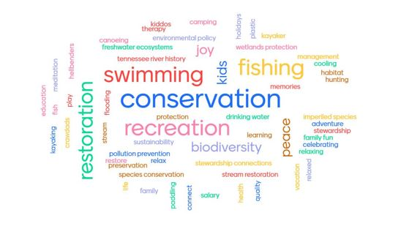

The program continued with the TRBN coordinator from Clemson University, Gillian Bee. Gillian shared the network’s 2020 achievements and business updates through its growing leadership and partnership. She opened with the update of officers, followed by the partnership survey, which indicated TRBN’s future focus on connectivity and non-point source pollution, and encouragement for integrating diversity and inclusion in future projects. TRBN efforts will continue to move on funding the website, and social media, with participation in the World Fish Migration Day in October. While microplastics has been identified as a priority of many TRBN members, the Network is waiting to hear the outcomes from a recent event held by The Tennessee Aquarium to identify effective next steps on this topic. See live poll results below:

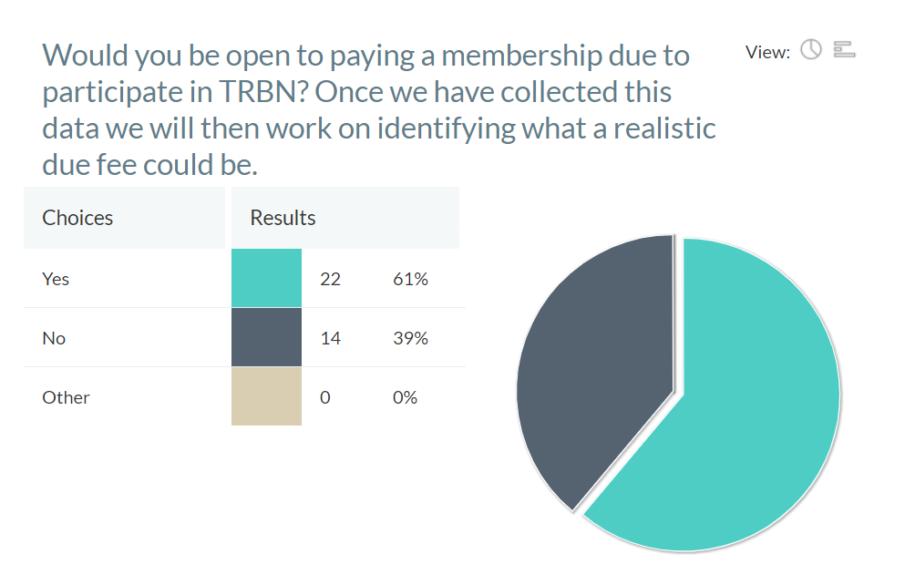

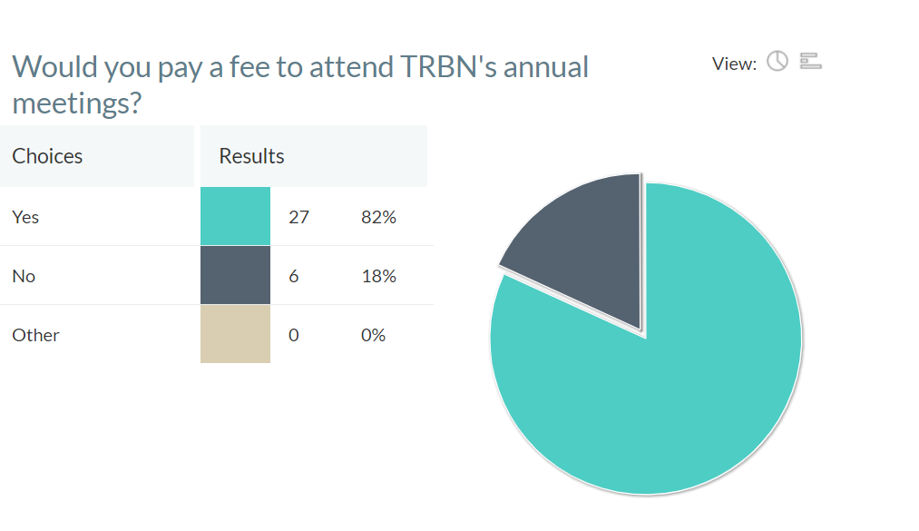
TRBN is moving forward on securing funding, providing training to NRCS field staff in TN on identifying win-win solutions for aquatic life and agriculture, and developing additional workgroups and an action plan. Gillian noted that the 2021 meeting will be in western North Carolina. The meeting then shifted to a series of connectivity presentations.
Dr. Jessica Graham of the Southeast Resources Partnership (SARP) launched her presentation, sharing the mission to protect aquatic resources through a focus on inventory, prioritization and connectivity teams to connect to on-the-ground barriers, not just dams, but also to understand road, railroad or other crossings, that fragment the ecological health to species. SARP tracks survey data which helps prioritization, determining barrier removal or fish improvement, by focusing on habitat, reconnecting healthy watersheds and be obsolete. The SARP Aquatic Barrier Prioritization Tool is available to use. Finally, the feasibility and conservation tools help to focus on narrowing down the potential for removing or remediating the barrier.
Rob Bullard of the Nature Conservancy and Pandy Upchurch of the Tennessee Wildlife Resources Agency continued the connectivity thread. Rob outlined the importance of key focus on habitat fragmentation, situation analysis, partnership formation, inventory and prioritization, and success. The concern for these issues is done by evaluating the state of habitat conversion, migration, stream function, and human safety. The Tennessee Aquatic Connectivity Team (TACT) is an informal, open group that brings together partners with an interest in barrier removal. Together they share project updates, experience, opportunities, and topical presentations to leverage partnership and achieve greater results, in addition to using the SARP prioritization tool.

Pandy provided her expertise on low-head dam removal for the TRBN meeting, focusing on the Harm’s Mill Priority Dam Removal using the SARP tool since the dam was the state’s top priority and could allow for better connectivity both on upstream and downstream sides of the river. It was also high for species diversity. So, with strong feasibility and conservation benefit, it was a good candidate for removal, but the state had to move forward with landowner contact, and the dam is on the National Register of Historic Places Registration Form. There’s also interest in the recreational quality of the dam, however, Harm’s Mill is a barrier to the free flow of the river and in addition to the obstruction, it’s also dangerous. Pandy ended with an overview of the Dam Removal Checklist, a guide as they consider all the elements they need to address in order to restore the free-flowing nature of the dam.

On Day 2, Heather Griffin of the Alabama Department of Environmental Management and John Lee of the NRCS National Water Management Center shared their presentations on NPS pollution. Heather indicated that land runoff, precipitation, atmospheric deposition, drainage, seepage, and hydrological modifications can cause NPS pollution. The Clean Water Act allows landowners and partners to implement NPS management programs through partnerships that help create a holistic approach for water management. Heather provided examples of two NPS pollution programs: first, Crowdabout Creek in Morgan County and second, Hester Creek in the Mountain Fork Watershed, both fish and wildlife streams. The leadership reviewed watershed management plans and determined the conservation practices such as load reduction to improve water quality and ultimately to delist the creeks with the support of numerous partners. Heather provided links to success stories in Alabama and other states as well as ADEM’s NPS program, and annual report.
John Lee shared his work on agricultural non-point source pollution. His focus was on pollutants, water quality, best management practices (BMPs), and conservation planning. John noted that sediment is one of the greatest contaminants in surface water runoff from agricultural land, followed by nutrients, and pesticides. Sediment is also the largest pollutant by volume of surface water in the US. John shared information on the nation’s water quality challenges, especially the greatest stressors – phosphorous, nitrogen, riparian cover and disturbance, and streambed sediment. Reducing sediment loads is a national priority as over 47% of streams have medium to high levels of phosphorus and over 53% have medium to high levels of nitrogen, impairing 14,000 streams with nutrient related issues and 2.5 M acres of lakes and reservoirs. The response is use of BMPs. BMP conservation plans are voluntary - used to protect, conserve, and enhance natural resources by using a systems approach for animal feeding operations, forestry, livestock management, water management and cropland management that is key to creating a positive effect on improving soil and water quality. The ultimate goal is to reduce environmental stressors.

Dr. Mounir Mikara of the City of Chattanooga’s Water Quality Program shared the city’s creative development of the East Lake Park Project - which included diverse and inclusion outreach in the community paired with improvement of water quality, including clean-up and restoration, integration of green infrastructure, educational spaces and sustainable design. Started program in 2016 and began reaching out to funders, including the Lyndhurst Foundation, with design and bid in 2018. Park opened in January 2020 with numerous partners. Design included a student competition on elements, with many community meetings to prioritize projects. The project included a high number of Spanish-speaking community members, so the city did surveys in both languages and used this for the concept design. The city reached out and labeled all trees and interacted with the community on design features before starting the project, such as a boardwalk, outdoor classroom, a natural playground focused on the community, and daylighting of the historic spring that had been put underground. Project manager David Mason from CDM helped with design and park improvements including lake restoration and fish structures and stocking, as well as meeting ADA requirements. Akosua Cook helped with the design and engagement for the natural playground and the integration with the community.

The program was capped by a breakout session, designed to help identify and shape next year’s TRBN program actions and priorities (see below regarding breakouts).
Highlighting the “soul” of the meeting was acknowledgement of the two TRBN award winners on September 15: Andy Hill of MountainTrue and the Watauga County RiverKeeper and Mary Beth Sutton of WaterWays of Chattanooga, TN. Both were celebrated for their ongoing support of the Network. Gillian Bee also “spun the wheel” for the raffle of a sicklefin redhorse quilt block. Following the ceremony, attendees shared entertaining stories of the river, water, and fish.
That lively mix of a sense of fun with connections across the virtual field provided a different meeting. Certainly, all would have preferred an in-person program, but both organizers and attendees noted that the mix of interaction with speakers and other participants, short films, video introductions, and games, brought people together – to the surprise of many.
More details on the program and results are below.

Actions, Outcomes, and Recommendations for Future Network Activities
Actions:
Many ideas were proposed within the breakout sessions on Day 2 on how the Network could work collectively to address nonpoint source pollution and aquatic connectivity (keeping in mind to be inclusive of the diverse stakeholders of the TRB). Proposed ideas will be discussed by the Network’s Steering Committee. Below is a brief review of key elements proposed in the discussions within the four breakout groups:
- Consider the strong interest for ShadeYourStreams (SYS), including a range of education and outreach to the lay person, improving data for prioritization, story maps, and microplastics, as well as seeking champions within schools through teacher in-services or outdoor classrooms
- Acknowledge the robust interest for action items including outreach and education to new audiences -- ranging from public outreach to agricultural partners to landowners with NRCS partners, connecting with school curriculum, engaging with other organizations, and more
- Discuss the TRB and the Southeast’s general cultural heritage of biodiversity that people would likely embrace, and be proud of, if they knew about it.
- Identify geographic focal areas
- Develop goals/targets related to connectivity that use a shared measurement system by which the TRBN shows success/collective impact
- Create a TRBN subcommittee on aquatic connectivity
- Identify the ‘desperate dozen’ (using a different name) projects to implement – and collectively work on together
- Research an agenda related to connectivity – best design options, etc.
- Inventory on-going and existing projects and success stories related to connectivity
- Think about non-traditional ways to more effectively communicate and educate local communities. (Past communication has not been effective.) This could include exploring creative outreach and branding of the region’s unique and biodiverse heritage, by
  - celebrating local endemic species, like a blue-mask darter, as a mascot for education and outreach programs,
  - partnering with local microbreweries, coffee companies, etc., to feature endemic and threatened species with limited edition beers, beans, etc.
  - pairing organizations with breweries and ask if a percentage of proceeds would be received by the organization to fund conservation efforts, and
  - creating a festival in a town to promote aquatic conservation
- Contact local media outlets to promote regional events and interesting stories.
- Make scientific literature accessible to non-experts by:
  - translating science to an 8th grade reading level
  - featuring a regular website feature, like a TRBN monthly blog post that translates scientific literature! This could be a work group activity (for the social media work group) or part of a coordinated social media blast among our partners when the issue comes out.
- Meet people from different geographies and backgrounds where they are, by:
  - talking about nontraditional workshops for education events -- even holding an event by partnering with a makeup company to sponsor a free makeup and makeover event, which provided an opportunity to address the community issue of diapers being improperly disposed of in local creeks.
  - considering going to non-traditional places, like churches or other important places in the community you are trying to reach, and make sure to adapt to the community’s customs!
- Considering a Farmer Field Day idea, to provide an opportunity for farmers to show off their properties, maybe demonstrate use of new, environmentally friendly agricultural techniques, or something similar. (One attendee noted this sounds like the educational workshops planned with the NRCS that TRBN was going to put on before COVID struck.)
The TRBN Steering Committee will need to convene and further explore the range of ideas, determining what the priorities are, the resources available to achieve them, the ability and interest of partners to commit to support these goals and direction, and what engagement looks like with the public and broader partners.
We recommend a deeper continuation of connectivity and non-point source pollution, by selecting three or four main goals and pursuing them, while keeping in mind the commitment to diversity and inclusion. To truly engage further in diversity and inclusion means the consideration of D&I at the forefront – engaging existing partners and reaching out to other groups and organizations and deepening relationships and understanding. This is not necessarily easy, nor is it a short-term venture, but a commitment to better understanding new partners and opportunities that are critical to increase the health and diversity of the aquatic realm as well as the people who live nearby and drink it, view it, recreate in it, and use it. The commitment that people make to protect the resources will be the pledge for ensuring the health of the TRB for a long time.

Contrasts between the 2019 and 2020 meetings are shown below:
2019 Data
- 62 participants and speakers represented 42 organizations
The Network goals for the meeting reflected consistency with prior years to:
- Engage with new people and new partnerships
- Glean new knowledge and identify collective priorities for action, and
- Celebrate Network achievements
Participants selected TRBN’s goals for 2019 through an action planning process that designated four key areas for implementing priorities with greatest support as follows:
- Seeking and securing funding for the TRBN Network and general support
- Addressing the threat of microplastics
- Developing the Web site and presence by engaging with TRBN partners
- Integrating social media across the TRBN

2020 Data
- Individuals present during live sessions ranged from 40-70.
- 124 total registrants
- 105 participated (NOTE: the definition of participated is different this year as prior years. we considered an individual as a participant if they accessed the online event guide. They did not have to attend the live meetings to be included as a participant.)
The Network meeting goals were to:
- Connect over Connectivity
- Share Solutions to Nonpoint Source Pollution
- Engage in Diversity and Inclusion
- Celebrate Network Achievements

Participation Profile (from 2019 to 2020
Shifting to the summary of overall registration, at the baseline level the 2020 meeting saw a significant increase in overall number of participants and organizations involved. Such changes were the strange changes from the program’s virtual aspects that enabled more people to attend without in-person travel risks from COVID-19 pandemic health restrictions.
2020 | 2019 | Difference
105 attendees | 62 attendees | 69% increase
59 organizations | 47 organizations | 26% increase in new organizations

2020 Slides of Pre-Participation Summary
