2020 Tennessee River Basin Network Meeting
September 15th-16th 2020
Virtual via CrowdCompass AttendeeHub App
Times displayed in Eastern Daylight Time

Day 1 – Tuesday, September 15th

SESSION #1: Welcome & Keynote Address
10:00 am | Welcome
Shannon O’Quinn, Tennessee Valley Authority

10:10 am | Meeting Objectives & Charge to Participants
Kendra Briechle, The Conservation Fund

10:20 am | Keynote Address and Q&A
Kathy Hoverman P.E., KCI Technologies, Inc.

SESSION #2: Short Films Session
11:oo am | Several short films will be streamed

SESSION #3: TRBN Business Update & Connectivity Success Stories
1:30 pm | Session Welcome
Kendra Briechle, The Conservation Fund

1:35 pm | 2020 TRBN Achievements
Gillian Bee, TRBN Coordinator, Clemson University

1:55 pm | Virtual Scavenger Hunt

2:00 pm | Southeast Aquatic Resources Partnership
Dr. Jessica Graham, Coordinator (SARP)

2:20 pm | Tennessee Aquatic Connectivity Team
Rob Bullard, The Nature Conservancy
Pandy Upchurch, Tennessee Wildlife Resources Agency

2:40 pm Connectivity Q&A

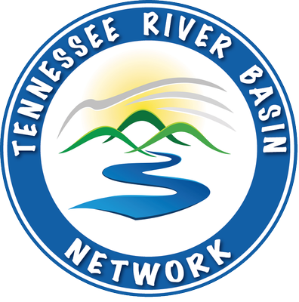

Day 1 continued

SESSION #4 Celebration & Networking Session

4:30 pm | Session Welcome
Kendra Briechle, The Conservation Fund
4:35 pm | 2020 TRBN Award Recipients
Gillian Bee, TRBN Coordinator, Clemson University
Shannon O’Quinn, Tennessee Valley Authority, TRBN President

4:50 pm | Sicklefin Redhorse Raffle Winner

4:55 pm | Virtual Social
Day 2 – Wednesday, September 16th

SESSION #5: NPS Pollution Success Stories
10:00 am | Session Welcome
Kendra Briechle, The Conservation Fund

10:05 am | Hester and Crowdabout Creek
Heather Griffin, Nonpoint Source Unit, Alabama Department of Environmental Management

10:25 am | National Water Management Center
John Lee, Natural Resources Conservation Service

10:45 am | NPS Pollution Q&A

SESSION #6: Acknowledging Diversity through Outreach & Inclusion
11:15 am | Session Welcome
Kendra Briechle, The Conservation Fund

11:20 am | East Lake Park Project
Dr. Mounir Minkara, P.E., Water Quality Program, City of Chattanooga, TN

11:40 pm | Q&A with Dr. Minkara

SESSION #7: Meet Your Network
12:00 pm | Brief introduction videos of Network members will be playing

SESSION #8: Virtual Breakouts & Meeting Close
2:00 pm | Session Logistics and Objectives
Kendra Briechle, The Conservation Fund
2:15 pm | Virtual Breakout Sessions
2:40 pm | Report Out & Next Steps
3:20 pm | Final Thoughts and Thanks from TRBN!
3:30 pm | Meeting Close

